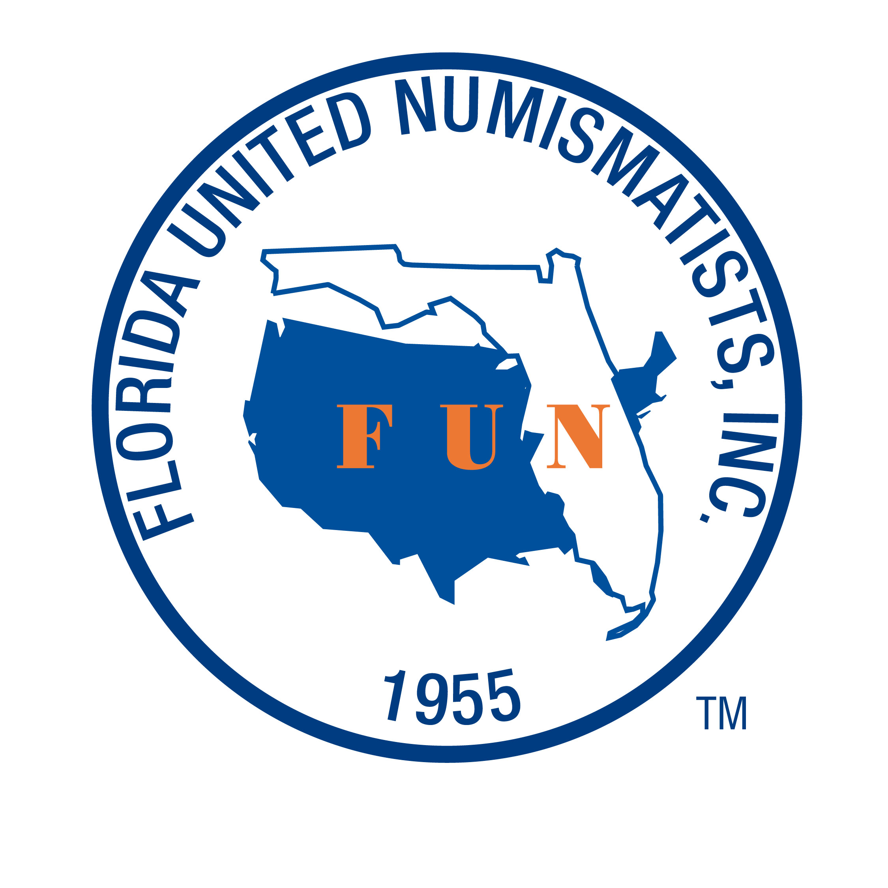

AUTHORIZATION TO SUBMIT WRITTEN MATERIAL TO THE EDITOR
OF FUNTopics MAGAZINE FOR YOUTH UNDER THE AGE OF 18

I am __________________________, the parent / guardian of __________________________, age _____, who is a Junior Member (Young Numismatist) of the Florida United Numismatists (FUN). I hereby authorize the Florida United Numismatists, Inc., to print her / his written article which they have submitted for inclusion in the FUNTopics magazine published by the Florida United Numismatists.
I verify that the submitted article is the original work written by __________________________________, and that ________________________________ has all copyright and intellectual rights to this article.
This article is a free contribution to the FUNTopics magazine section YN THOUGHTS, which is a way for Young Numismatists to express their experiences and feelings about coin collecting.
I hereby authorize Florida United Numismatists the right to reprint, distribute, publish, or otherwise disseminate this article and copies of same as they see fit, holding FUN harmless as against any repercussions that may result from publishing said work in FUNTopics or any other platform upon which that work is published by FUN with my permission.
The author, ________________________ retains all copyrights or other intellectual property rights to the publication and may reuse any portion of the article in future publications or speaking engagements, personal use, and may post a copy of this article on the author’s own or another’s website.
The author ________________, and his/her parent(s) hereby agree to release FUN from any and all liability for actual or alleged damages to me and to hold FUN and any of its officers, associated board members, employees, contractors/subcontractors, volunteers, and sponsors/underwriters, harmless from any damages or liability arising from any civil or other legal matters related to publishing the article in FUNTopics, whether such legal matter arises from or be brought by the YN, parent/guardian or any person claiming copyright, intellectual or other property rights to the article and/or its contents.
The undersigned parent of _______________________ agrees to and freely consents to the terms contained herein and the signature below confirms such agreement.

Dated: _____________ in ___________________(city) and ___________________(state).

____________________________
Printed name of Parent / Guardian

______________________________
Signature of Parent / Guardian

